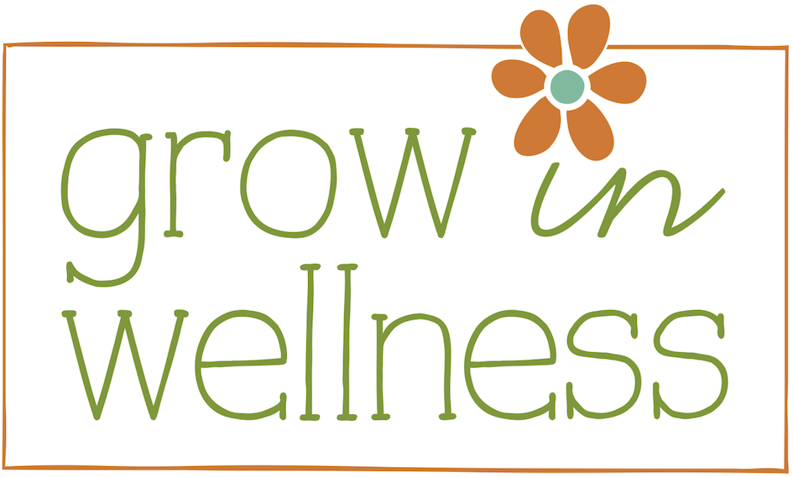

Green Breakfast Bowl
By Carla Matthews

Makes 2 servings

1 cup cooked oatmeal
1 cup cooked quinoa
½ cup of almond milk
½ tsp. cinnamon
½ tsp. maca
½ tsp. vanilla
1 tsp. raw honey
1 tbsp. hemp seeds
¼ cup organic blueberries (you can use frozen)
¼ cup fresh organic spinach, lightly chopped
1 tsp. cacao nibs, divided

Start with one cup of just cooked, hot oatmeal (I like Bob’s Red Mill gluten free oats). Add in one cup of cooked quinoa (I use leftovers from a previous meal). Then, under low heat, (because the idea is to warm the ingredients together, not cook them) add the almond milk, cinnamon, maca, vanilla, raw honey, hemp seeds and blueberries. Combine until warmed through and remove from heat. Stir in the spinach and divide into two bowls. Top each bowl with a half teaspoon of cacao nibs and serve. Gently combine until warmed through, then remove from heat and…
mix in ¼ cup fresh, lightly chopped spinach (yes, greens in your oatmeal!). Place into two serving bowls, top each with a ½ tsp of cacao nibs and serve.

www.growinwellness.com

