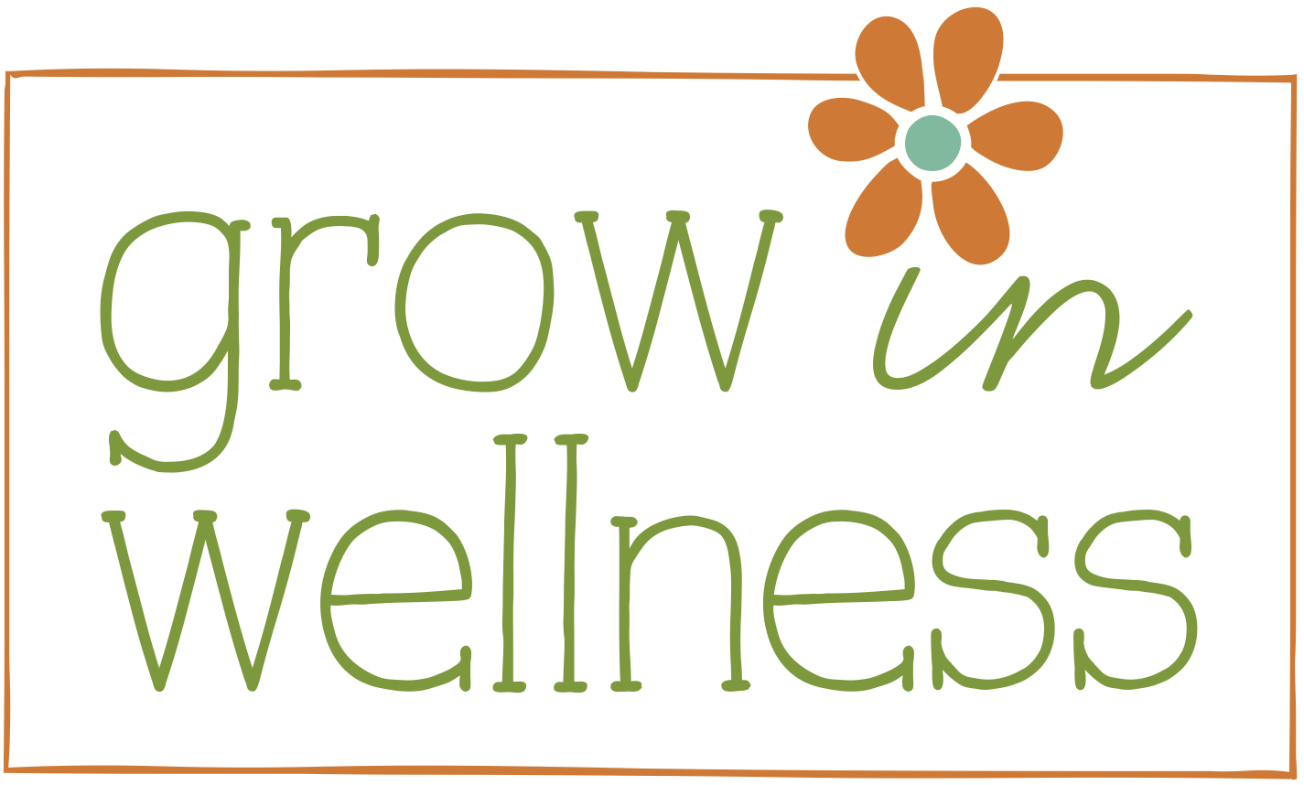

Baked Oatmeal Cups

1 tsp. aluminum-free baking powder
½ tsp. fine grain sea salt
2 cups rolled oats
¼ cup walnuts, almonds or pecans, chopped
¼ cup 100% pure maple syrup
1 tsp. ground cinnamon
1 ½ cups of milk (almond, hemp or cow)
1 large egg (or ½ c. mashed banana to make this vegan)
1 ½ TBSP of melted unrefined coconut oil (or butter)
2 tsp. pure vanilla extract
Toppings: fresh blueberries, sliced fresh strawberries, chopped nuts

- Preheat oven to 375 degrees. Line muffin tin with unbleached parchment liners.
- Combine baking powder, salt, cinnamon, oats and nuts in a large bowl
- In a separate, medium bowl, whisk together milk, maple syrup, egg, melted coconut oil and vanilla
- Pour the wet mixture into the dry mixture and stir to combine. You can add fruit to the mix at this point if you want all the cups to be the same.
- Ladle the oat mixture into the prepared muffin tin, about ¾ full.
- Sprinkle additional nuts on top or if you haven’t added the fruit, you can top each one differently with blueberries or strawberries.
- Bake for 20-25 minutes or until set and wet ingredients are fully absorbed. Eat warm or at room temperature. Leftovers can be stored in the refrigerator (for up to 5 days) and re-heated as needed.

